Offline Social Gold



Steal My Offline Social Blueprint On Making $5000 Per Month!

Thankyou for purchasing this report on Offline Social Gold. Now I am sure you have heard lots of ways to make money offline from local business owners. There are lots of business models and different ways to pitch to a local business owner.
However, in this report I am going to focus on a very popular business model which has not only proven to work for me but it has also given me an additional revenue stream!
In this report I am going to talk about a really cool, powerful strategy that involves doing something for business owners for free and then cashing in at the backend.
I have not seen anyone do this before. With all my cash cow reports I love getting straight to the point without boring you too much.
I hope you enjoy Offline Social Gold and I hope you start taking action today.
Imran Naseem

http://www.RagstoRichesForum.com
http://www.ImranNaseem.com
http://www.Facebook.com/ImranNaseem

Getting Started
With the explosion of the offline niche more and more people are looking to make money from local business owners. Local business owners are always looking to generate clients and get more business. From car traders to local hairdressers the fact of the matter is that all business owners need clients in order to succeed.
Just the other day I was speaking to a car trader and he asked me to help him “Generate more business” and the first thing that came into my mind was social media. I immediately talked about Facebook and Facebook Fanpages. He became eager and as a result of this I arranged an appointment with him in regards to creating a Fanpage ☺
How easy was that?
This guy was prepared to pay me for a Fanpage?
Now in this report I am not going to talk about selling Fanpages but using a powerful business model.
This method involves creating “free Fanpages for local business owners” and then making money at the backend.
Now I know what you’re thinking.
“Imran, you fool. If I create a Free Fanpage, how the hell would I make money at the backend?!”

I am going to be coming to that. The first thing you need to do is create a FREE Fanpage for a Local business owner.
However, before anything else we are going to be getting Local business owners to contact us for this FREE Fanpage offer.
And the best way to use this business model is to use the power of Flyer Marketing and Car Flyers.
Now believe it or not Flyer Marketing and Car Flyers are powerful offline marketing tools.
So the first thing you need to do is simply go out there and find a Flyer printing company who can create you a basic flyer for your offline marketing campaign.
Now your Flyer should look something like this.

Is Your Business On Facebook?


Want Thousands Of People Talking About Your Business In A Short Space Of Time?

FREE Facebook Fanpage With Targeted Fans
Limited Offer
Call Now XXX-XXX-XXX

Now as you can see this is a simple, yet powerful flyer that will attract business owners in calling you.
The key word to use is the FREE word because it will attract a lot of business owners to contact you in a short space of time.
Here is what I would do at this stage.
Look for someone who can create you eye-catching flyers. You can easily outsource this to someone on Elance or Odesk for cheap.
Fiverr.com also has excellent Gigs you can purchase for $5.00 where people are willing to create you attractive flyers.
Here is a really popular Gig you can use.
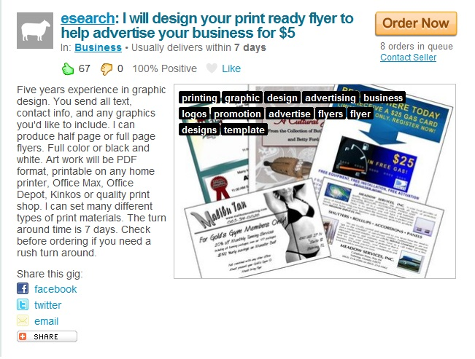

Now make sure you ask your graphics designer to use a lot of different “call to action” features on your flyer. Words such as “FREE” and “Limited offer only” will help to attract more clients and get them ringing you.
The FREE Business model is powerful, if done right.
The next thing to do is start distributing these flyers so business owners can contact you.
If you cannot afford a distribution flyer company simply start handing out flyers at cafes, restaurants, libraries and other places.
Business owners are everywhere!
Here are some Gigs that you can use from Fiverr where people are willing to distribute your Flyers for $5.00 at different various locations.
If you want to spread word out about your consulting business then you can use the following Gigs.
Here is a Gig that can spread news about your “Free Fanpage” service in a short space of time.
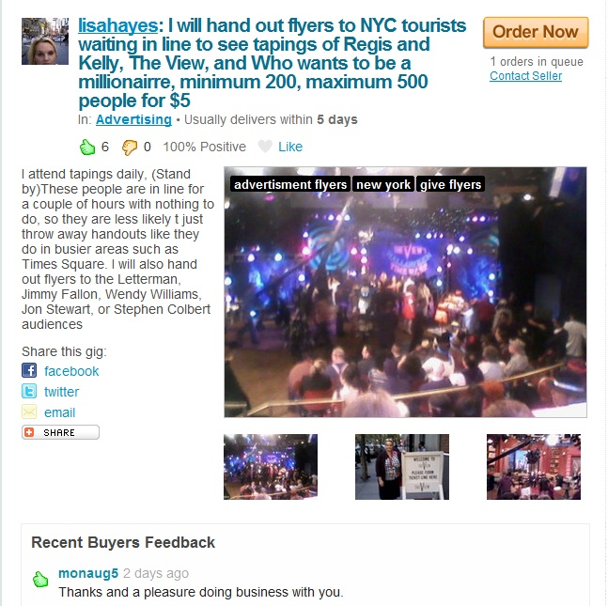

Now I am sure a lot of business owners will be interested in a “Free Fanpage” but what about normal ordinary people who want to brand their venture?
This Gig is an ideal one if you wish to spread word of mouth about your service in a short space of time.

Remember when I talked about car flyer advertising? Here is a brilliant Gig on Fiverr; it does everything as it says on the tin.

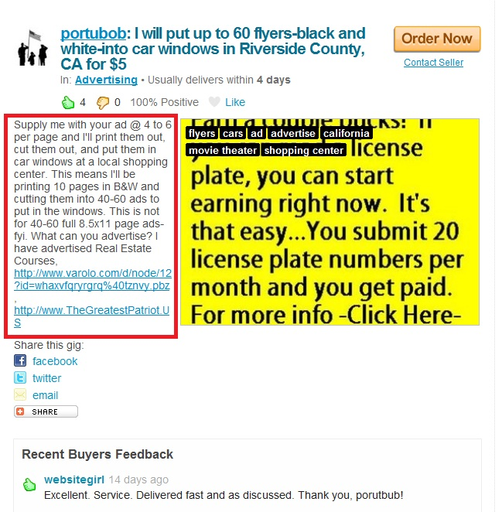

Now imagine the number of business owners who will be going to local shopping malls?
There will be lots of them!
And if that is not enough this cool Gig on Fiverr will also help you get lots of clients in a short space of time.

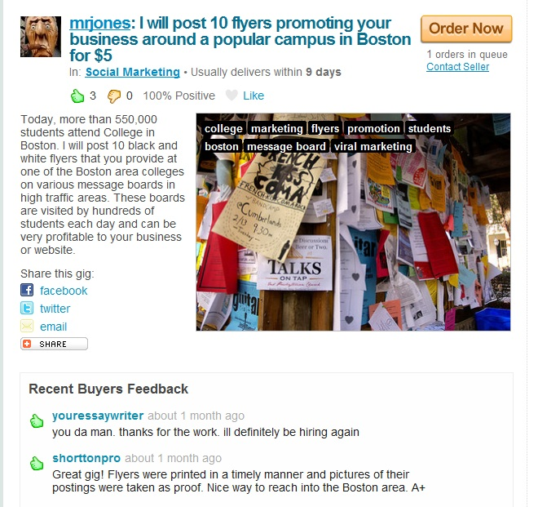

As you can see this Gig is offering to post 10 flyers on Boston College campuses.
Imagine the response you will get?
If you are going to be targeting foreign clients then simply put down an email address or a skype Id.
Once you have posted your flyers in targeted places the next thing to do is simply wait until someone contacts you.
Now because Flyer marketing is powerful and word of mouth spreads fast you will find that a lot of business owners will take you up on your FREE Fanpage offer.
Once you have your first client ringing you then you simply need to find out about his/her website and the type of Fanpage they would want created.
Now this is where it gets interesting and where you will be able to make more money at the backend.
When you create a Fanpage for a local business you will need to make it clear to them that this FREE offer is for a Fanpage only plus targeted fans.
Before I go further the best way to get targeted fans is to head over to Odesk and post your job listing and see what people are offering.
For example, here is someone wanting targeted Facebook fan’s for his “game” Fanpage.
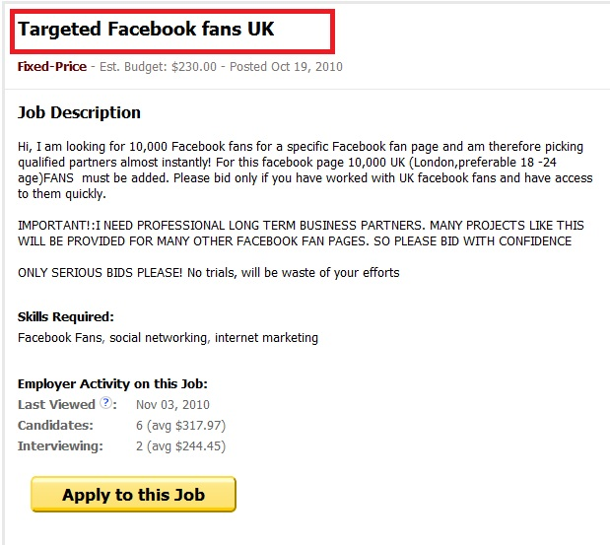

As you can see 6 candidates have already applied for this job posting.
This person is looking for targeted Facebook fans.
It is no good creating a Facebook Fanpage for a business owner by simply having random fans. If you have targeted fans then the business owner will most likely to do business with you in future.
There are lots of services you can find on Google that offer Facebook fans for cheap. Some companies do bulk discounts.
You can check out http://facebkfans.com/ - these guys offer different plans. For just $39.97 you can buy 1000 targeted Facebook fans.
However, do not simply go out there and start buying fans left right centre. Make sure you do your research beforehand. I would simply use services such as Fiverr and Odesk and Elance to find people.
The business owner will be happy to take you up on your offer for your Free Fanpage service. However, it would not be ideal to simply offer a free service to the business owner. This is the stage where you can make money.
As you might be aware Facebook Fanpages allow you to add landing pages and Auto responders.
For example, take a look at this landing page for a game Fanpage.
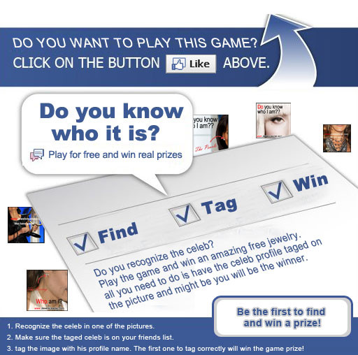

As you can see this has lots of call to action features.
By including a landing page you can charge the business owner extra money at the backend.
However, that is not all.
If you wish to add an Opt in page to your Facebook Fanpage then it is pretty much easy.
All you need to do is click the “Edit Page” on your Fanpage until you see a screen that looks like this.
(See Below).
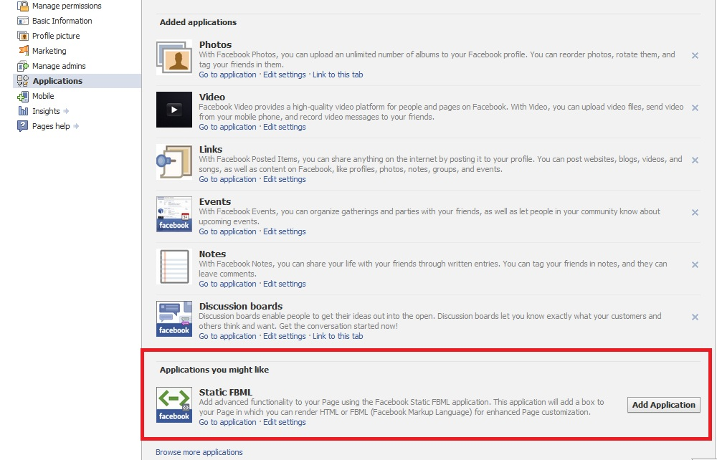

Simply click the Static FMBL link by clicking “Add Application”.
Once you click “Add Application” this application should then show up on your Fanpage.

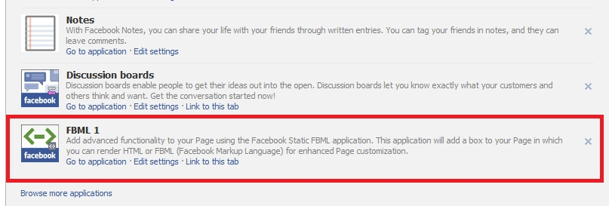

The next thing you need to do is click “Go To Application”.

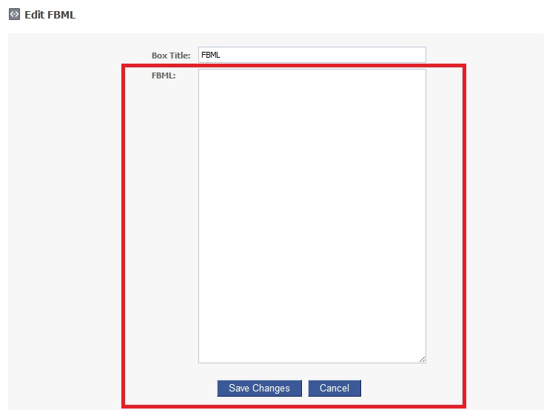

Next simply log in to your Auto responder and paste the code onto your FMBL page.
This will then allow you to capture the name and email address of anyone.
Now to a business owner if you told him about this imagine the response you will get.
“Hi, Mr Business Owner. Thank you for taking me up on your FREE Fanpage offer. I will create a free Fanpage for you. However, did you know for just $197 I can include a feature that will allow you to capture people’s data. Imagine if you were able to capture thousands and thousands of leads from Facebook with just a click of a button? That is possible with this package.
I can also include a landing page for you (professionally designed) so that anyone who lands on your Fanpage is most likely to click “Like” and join.
Remember these are going to be targeted Facebook fans who will be interested in your business.
How does that sound?”

Now when it comes to pricing your backend Fanpage service you have the option to charge a monthly FEE or a one off fee.
Do not tell the business owner about Aweber or how you are going to do this. Remember you are the marketing expert and you are going to monetise their Fanpage by including this “powerful feature”. To a business owner this is “groundbreaking” but as an Internet marketer we are pretty much familiar with Autoresponders and landing pages.
When it comes to creating your business owner’s Aweber account I would do the following.
- Create a brand new Aweber account. Aweber also gives a risk free 30 day trial and then charges $19.00 per month for up to 500 subscribers.
- Include the name and address of the business on your Aweber account. So when people from Facebook sign up they know that the email they are going to receiving from is the business itself.
- Price your service monthly or one time fee. It is up to you to decide which is the best option for you. I personally prefer a monthly fee because residual streams of income can add up

For example, if you had 20 people paying you $197 for this backend service that is $3940 a month.
However, if you had 50 business owners all agreeing to pay you $197 a month for your Fanpage backend service then that works out at $9850 per month (nearly $10,000!).

So in a nutshell this is what you need to do.
- Offer a FREE Fanpage service to a limited number of business owners
- Create Flyers and start distributing them – purchase a few Gigs on Fiverr and post jobs at Elance and Odesk
- Get Targeted Fans to the Fanpage
- Offer your Fanpage backend service to Local business owners and build a portfolio as a Fanpage expert! ☺

I hope you enjoyed Offline Social Gold report and I hope you take action.
If you liked this report please do not forget to leave a review.

Thankyou.

Imran Naseem

http://www.RagstoRichesForum.com
http://www.ImranNaseem.com

